Introduction: In order to clear small GR/IR discrepancies, we will use transaction MR11 (and MR11show to cancel).

Normally the accounting department or controlling department is doing that (the difference goes in Profit or Loss). Document type is KP

- Selection screen
One must be careful with default values proposed by SAP. Fields highlighted in red below have to considered
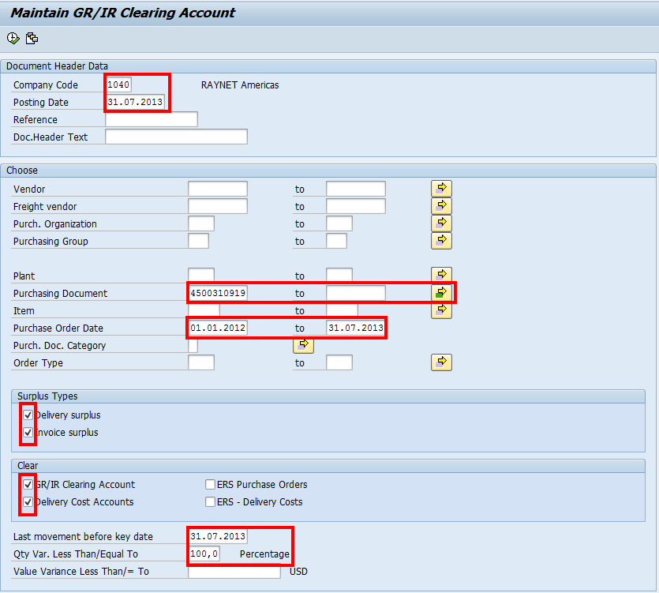

- Execution screen

Then you select the lines and save/post :
